**DEEP2NEURON TECH ACADEMY-INTERNSHIP 2023**

**DAY 2 - 20.06.2023**

On the second day, the task was to create our own datasets with binary class or multi class. I have chosen the binary class dataset.

**TOPIC :** Aquatic animals classification

I have selected Star fish and Jelly fish as two classes and downloaded a zip file each with 300 images and extracted all. Then, created a folder named aquatic animals classification and inside it created two sub folders named star fish and jelly fish. After that, inserted all the photos to it respectively. On each folder, gone through each image and cleaned them. Finally, I uploaded the same in my google drive with the folder name aquatic animals classification. It took some for upload as the file size is large.

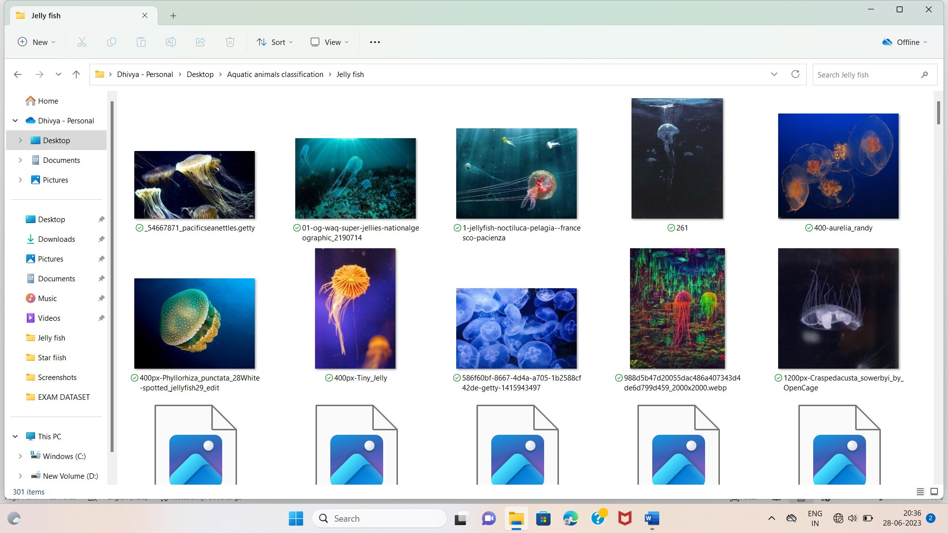

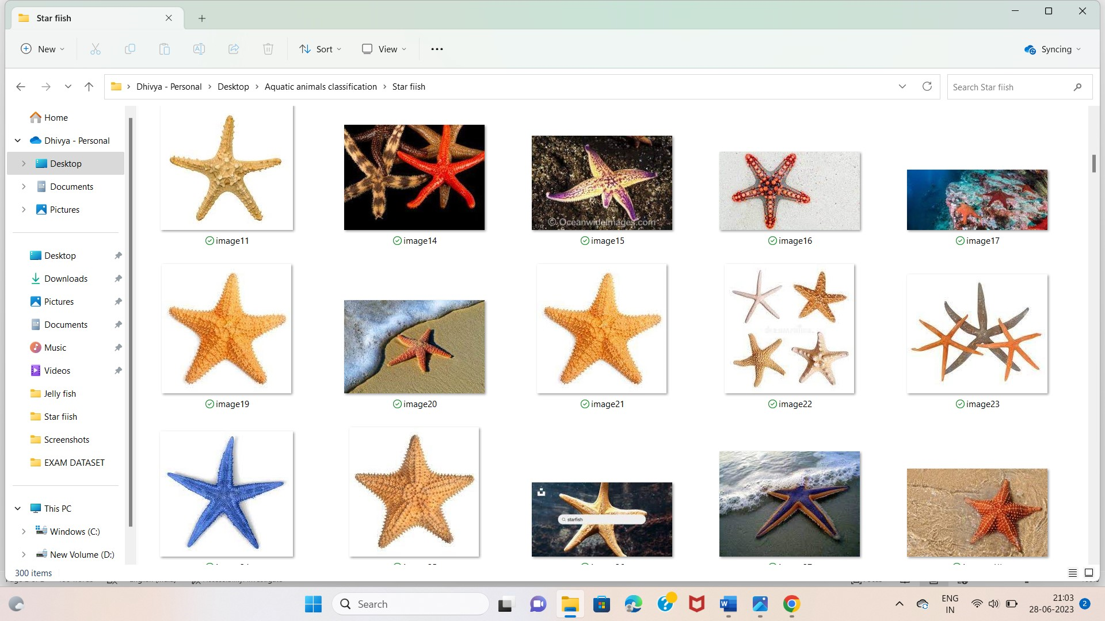

In the meet, I created three subfolders named test, train and validation in the folder where I uploaded my dataset. From each class, I selected 50 images and copied to the test folder. Similarly, for the train I copied the remaining images. Atlast , for validation I selected 30 images from the train folder.

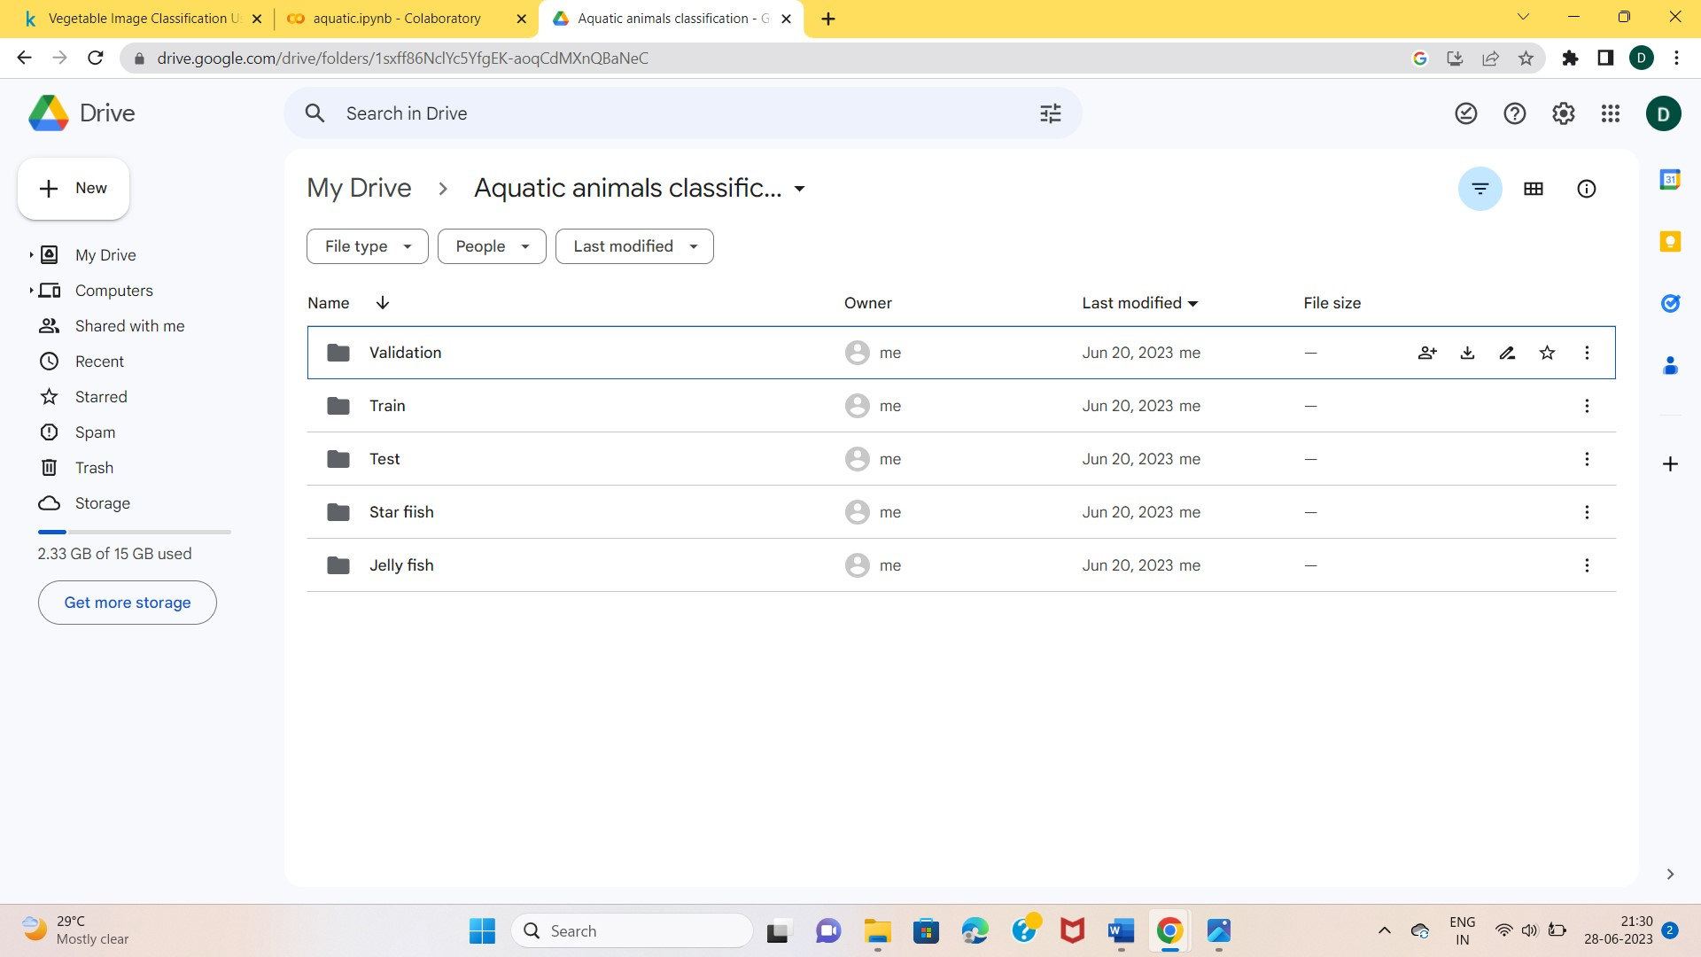

I mounted my drive in the Google Colab and started learning on how to use this dataset. After that the following steps are implemented with code:

**Step 1 :** Importing the necessary libraries

**Step 2 :** Visualizing the images

**Step 3 :** Preparing the dataset

**Step 4 :** Building the CNN model

**Step 5 :** Model training

**Step 6 :** Graph execution and predicting the labels

Errors were deducted in some cases and it was corrected accordingly. I understood the usage of the libraries used. I ran the each step in google colab and executed the output. By running the each step, I got some idea on how to visualize the images, why these libraries are imported and more. It got a small overview of CNN algorithm but not completely about it. The following images are the outputs of the above mentioned steps.

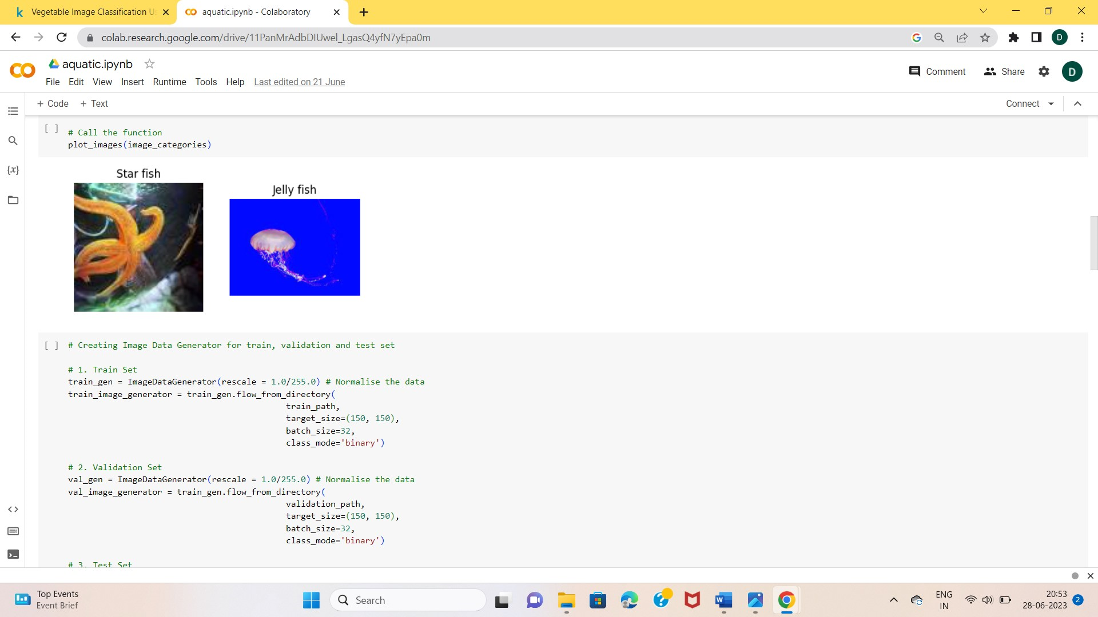

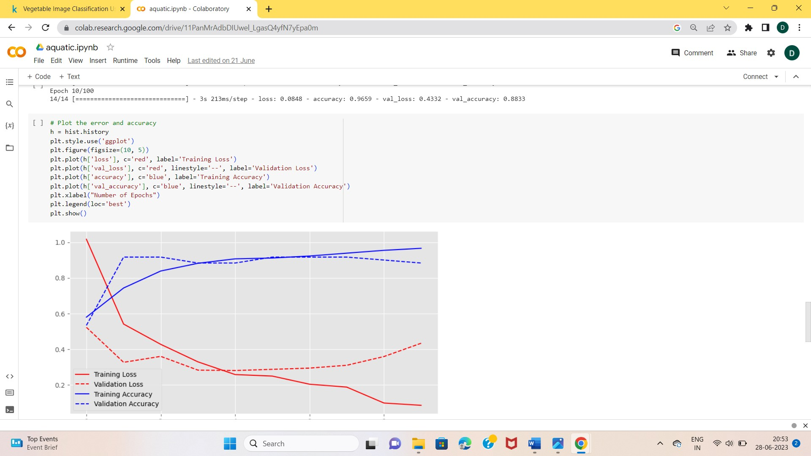

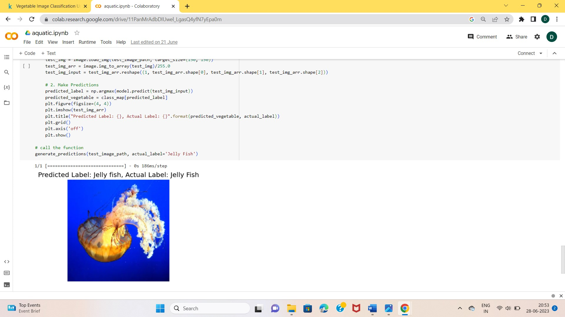

**LEARNINGS :**

* Attained knowledge on how to create a own dataset and mount it on google colab.
* Learnt the steps to change the code according to our dataset.